|  |
| --- |
| 1929 |
| Helensvale State School |

2017

**ANNUAL REPORT**

**Queensland State School Reporting**

***Inspiring minds. Creating opportunities. Shaping Queensland’s future.***

*Every student succeeding. State Schools Strategy 2017-2021*

Department of Education

|  |
| --- |
| Contact Information |
|  |

|  |  |
| --- | --- |
| Postal address: | 8 Lindfield Road Helensvale 4212 |
| Phone: | (07) 5556 1333 |
| Fax: | (07) 5556 1300 |
| Email: | principal@helensvaless.eq.edu.au |
| Webpages: | Additional reporting information pertaining to Queensland state schools is located on the [*My School*](http://www.myschool.edu.au/) website and the [Queensland Government data](http://data.qld.gov.au/) website. |
| Contact Person: | Micheal Shambrook Principal |

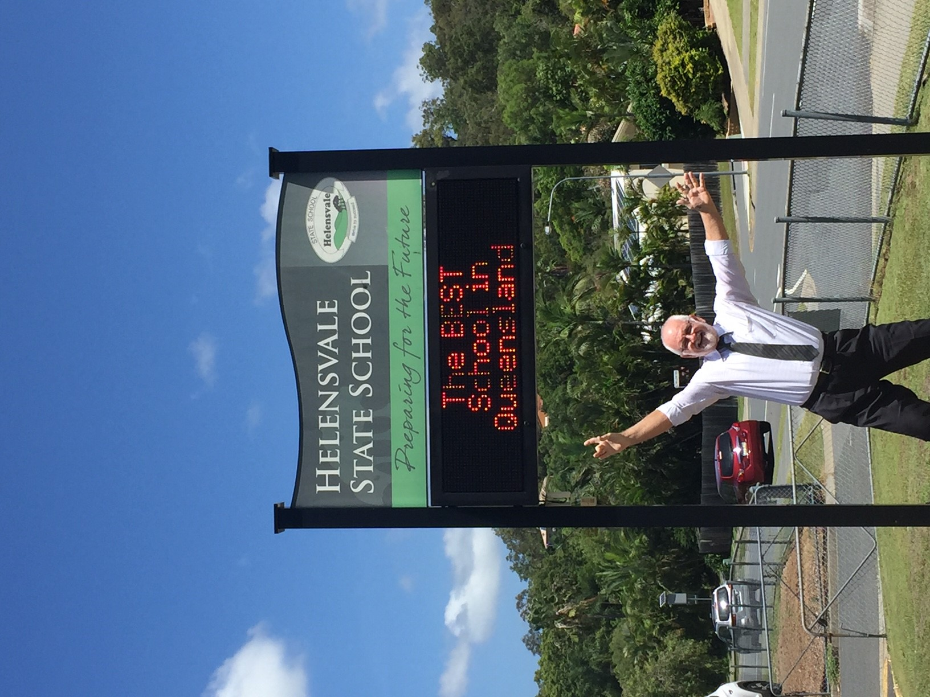W

tog

|  |
| --- |
| School Overview |
|  |

Our school caters for Prep - Year 6 and is situated on the northern Gold Coast with a current enrolment of over 1080 students.(June 2018). Through high levels of learning and wellbeing, our mission is for all students to learn.

Our three school rules

**Be Safe, Be Respectful** and **Be a Learner,**

guide our students to live by our school motto.

**Strive to Succeed**

Through quality teaching and learning we aim to personalise the learning of every student to support the achievement of their individual learning goals.

Students have access to academic, language, arts, sporting and music programs with specialist

teachers. Our students are proud to wear their school uniform which is well recognised in the Helensvale community and provides children with a sense of belonging and security. We value parents as partners in their child's education and develop strong partnerships with all members of our community to support our students in their pursuit of excellence. Parents work in partnership with our staff to prepare our students for a lifetime of learning. When you make Helensvale State School your school of choice, we accept this responsibility seriously as we strive to maximize the learning of every child in our care.

Vision: *“****United to inspire all minds to live, learn and lead successfully”***

|  |
| --- |
| Principal’s Foreword |
|  |

**Introduction**

**School Progress towards its goals in 2017**

This report provides parents and members of the school community with information about the school’s activities and performance during the 2017 school year. It highlights strengths and identifies areas for development and improvement. The School Annual Report is a public document required for schools and Education Queensland’s accountability and improvement purposes.

It provides valuable information for Education Queensland and members of the school community on the achievement of the school in relation to declared systemic and school priorities as outlined in the 2017 Annual Implementation Plan (AIP).

The report fulfils 3 functions:

1. Provide the school community, through the Parents and Citizens Association, with information on the school’s progress towards achieving the goals and priorities outlined in the Annual Implementation Plan (AIP).

2. Provides the Assistant Regional Director (ARD) with information to guide discussions about both the school’s progress towards achieving organisational goals and the priorities of the school.

3. Provides a base on which the school develops its next AIP. The report provides information for prospective and current parents about our school, including size, subjects offered, qualifications of staff, results of School Opinion Surveys (SOS) and school performance in NAPLAN testing for years 3 and 5 and other key information.

**Future Outlook**

The school will continue to work on these priorities in 2018 and continually monitor progress of the our year Strategic plan. Data will continue to be used to monitor success of students including

* Attendance
* Reading
* Spelling
* Science (including STEM)
* Quality Assessment
* Differentiation for Inclusion

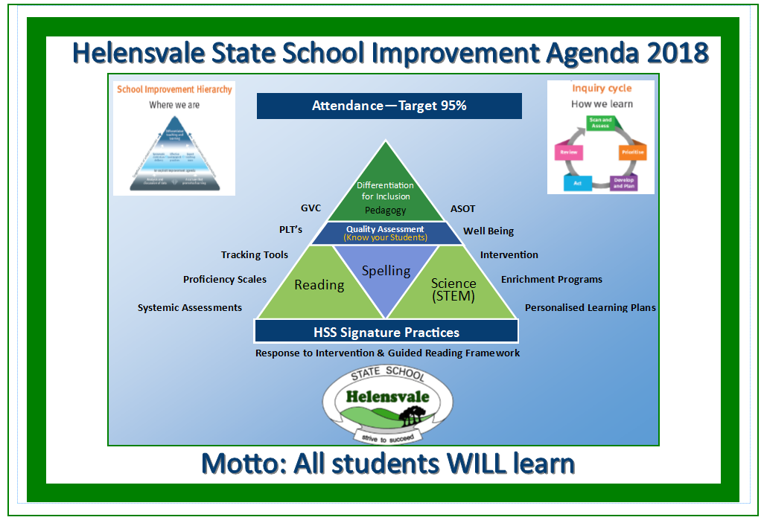

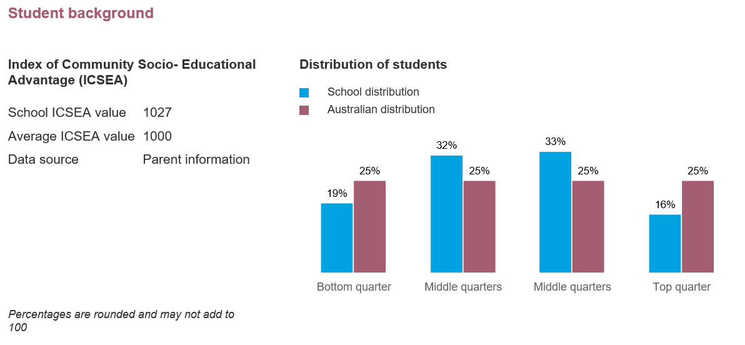

|  |
| --- |
| Our School at a Glance |
| **School Profile**   |  |  |  |  |  |  |  | | --- | --- | --- | --- | --- | --- | --- | | **Coeducational or single sex:** | | | Coeducational | | | | | **Independent Public School:** | | | No | | | | | **Year levels offered in 2017:** | | | Prep Year - Year 6 | | | | | **Student enrolments for this school:** | | |  | | | | |  | **Total** | **Girls** | | **Boys** | **Indigenous** | **Enrolment Continuity**  **(Feb – Nov)** | | | **2015** | 1043 | 519 | | 524 | 33 | 95% | | | **2016** | 1059 | 519 | | 540 | 39 | 95% | | | **2017** | 1065 | 516 | | 549 | 33 | 96% | | | Student counts are based on the Census (August) enrolment collection. | | | | | | | |

In 2017, there were no students enrolled in a pre-Prep** program.

** pre-Prep is a kindergarten program for Aboriginal and Torres Strait Islander children, living across 35 Aboriginal and Torres Strait Islander communities, in the year before school (<https://qed.qld.gov.au/earlychildhood/families/pre-prep-indigenous>).

**Characteristics of the Student Body**

**Overview**

The school is structured in 42 single year classes from Prep – Year 6 with the majority of the student enrolment living in the local Helensvale area. Students travel to the school using a range of transport modes including: walking, car, bike and bus. Eight different bus routes service the school community.

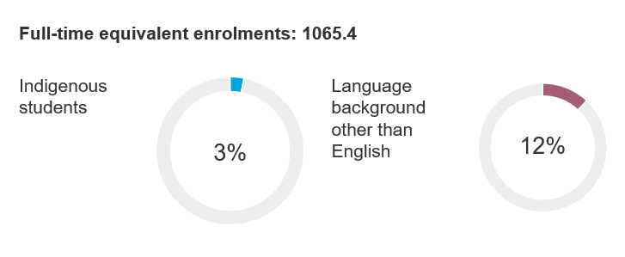

The socio-economic status of families enrolling at the school is diverse ranging from parents who have professional careers to Centrelink recipients A growing number of students with English as a Second Language (12%) attend our school as do students who identify as Indigenous (3%).

Helensvale State School is committed to valuing student voice and providing a range of student leadership opportunities.

In 2017 these included leaders /captains for:

* School, Class, Sport, Library, Music, LOTE, Eco, Student Council, Playground Mentors and Games Leaders. Student Council Committees included: Free Dress Day Committee, Disco Committee.

**Average Class Sizes**

The following table shows the average class size information for each phase of schooling.

|  |  |  |  |
| --- | --- | --- | --- |
| **AVERAGE CLASS SIZES** | | | |
| **Phase** | **2015** | **2016** | **2017** |
| Prep – Year 3 | 24 | 24 | 23 |
| Year 4 – Year 6 | 28 | 27 | 27 |
|  | | | |

**Curriculum Delivery**

**Our Approach to Curriculum Delivery**

Curriculum offerings include English, Mathematics, Science, HASS (History and Social Studies), The Arts, Health and Physical Education. ICTs are embedded across the Curriculum. LOTE (Japanese) is taught to all students in Years 5 and 6. Swimming is offered to students in Year 1 – Year 5.

Instrumental Music (Strings and Multi) is available to students from years 3 - 6. Children are also able to participate in Choir. The school is continuing to develop its Curriculum Framework in line with the

Australian Curriculum.

**Co-curricular Activities**

During 2017 children were able to take part in a wide range of extra curricula activities. The major events and activities available to our students during this period included:

• Year level excursions to complement class units of study

• Year 6 Camping program

• Athletics, Cross Country and Swimming Carnivals

• Student leadership activities

• Under Eights Week Activities

• Band and Choir participation

• Gold Coast Eisteddfod

• Coordinated activities with various aged care facilities

• School Discos

• Wipe Out Waste Program

• Environmental activities

• Out of school hours activities such as fitness programs, AFL, Auskick, and Soccer

• Year level social activities

• Instrumental Music – approximately 98 students participated in this program and were involved in a range of out-of-school-hours performances

• School Incursion Sports AFL and Rugby League.

• “Helensvale’s Got Talent” (talent quest) for Students in Years 3-6. An annual event which was extremely popular.

• Gardening Greenies – students participated in weekly gardening activities

• Buddies – senior students buddy with Preps in a range of activities

**How Information and Communication Technologies are used to Assist Learning**

Our school vision for ICT is that:

Information Communication Technologies can accelerate, enable, improve and transform student learning opportunities in all key learning areas and phases of learning. Through a range of digital learning technologies, our students are empowered to engage with technology to be successful citizens. We recognise that Digital Literacy is vital for students to become confident, creative and productive in a digital world.

Our school has a STEM (Science, Technology, Engineering and Mathematics) committee that is developing action plans around STEM and how we can best support our students.

**Social Climate**

**Overview**

Helensvale State School strives to create and develop a caring and co-operative educational environment for individuals through an enthusiastic, professional commitment to excellence, which reflects a genuine love of and care for children.

Our School‘s Responsible Behaviour Plan focuses on developing a supportive school environment and responsible, positive behaviour in all students and staff. The Plan provides a framework for creating an environment for each learner to develop responsible self-management, whilst learning about how and why people behave the way they do. The framework encourages students, staff and community members to critically reflect on behaviour, problem solve and develop strategies to support individuals to become socially responsible citizens.

**The school is child centred and student opinion is highly valued.**

Helensvale State School has developed a positive reputation in both the local and wider community, for our high expectations of students and for our caring learning environment. The multicultural enrolment at our school develops our students’ racial, ethnic and cultural understanding and tolerance as well as enriching our learning activities and experiences with input from other cultures.

An enthusiastic Student Council and a team of capable student leaders make a very positive contribution to student support and day-to-day activities in the school and wider community. Our school currently operates a range of programs that provide scaffolding for students at risk / requiring assistance and extension.

**Parent, Student and Staff Satisfaction**

**Parent opinion survey**

| **Performance measure** | | | |
| --- | --- | --- | --- |
| **Percentage of parents/caregivers who agree# that:** | **2015** | **2016** | **2017** |
| their child is getting a good education at school (S2016) | 91% | 90% | 87% |
| this is a good school (S2035) | 95% | 94% | 92% |
| their child likes being at this school* (S2001) | 94% | 97% | 93% |
| their child feels safe at this school* (S2002) | 95% | 95% | 94% |
| their child's learning needs are being met at this school* (S2003) | 90% | 91% | 86% |
| their child is making good progress at this school* (S2004) | 89% | 89% | 85% |
| teachers at this school expect their child to do his or her best* (S2005) | 96% | 98% | 93% |
| teachers at this school provide their child with useful feedback about his or her school work* (S2006) | 88% | 91% | 87% |
| teachers at this school motivate their child to learn* (S2007) | 90% | 94% | 89% |
| teachers at this school treat students fairly* (S2008) | 87% | 86% | 81% |
| they can talk to their child's teachers about their concerns* (S2009) | 97% | 94% | 91% |
| this school works with them to support their child's learning* (S2010) | 88% | 89% | 90% |
| this school takes parents' opinions seriously* (S2011) | 85% | 88% | 84% |
| student behaviour is well managed at this school* (S2012) | 81% | 82% | 84% |
| this school looks for ways to improve* (S2013) | 93% | 92% | 85% |
| this school is well maintained* (S2014) | 96% | 93% | 86% |

**Student opinion survey**

| **Performance measure** | | | |
| --- | --- | --- | --- |
| **Percentage of students who agree# that:** | **2015** | **2016** | **2017** |
| they are getting a good education at school (S2048) | 95% | 98% | 97% |
| they like being at their school* (S2036) | 96% | 94% | 95% |
| they feel safe at their school* (S2037) | 92% | 96% | 97% |
| their teachers motivate them to learn* (S2038) | 98% | 97% | 97% |
| their teachers expect them to do their best* (S2039) | 98% | 100% | 98% |
| their teachers provide them with useful feedback about their school work* (S2040) | 94% | 93% | 96% |
| teachers treat students fairly at their school* (S2041) | 98% | 89% | 91% |
| they can talk to their teachers about their concerns* (S2042) | 92% | 92% | 92% |
| their school takes students' opinions seriously* (S2043) | 96% | 87% | 94% |
| student behaviour is well managed at their school* (S2044) | 76% | 83% | 93% |
| their school looks for ways to improve* (S2045) | 97% | 96% | 98% |
| their school is well maintained* (S2046) | 90% | 95% | 91% |
| their school gives them opportunities to do interesting things* (S2047) | 96% | 92% | 96% |

**Staff opinion survey**

| **Performance measure** | | | |
| --- | --- | --- | --- |
| **Percentage of school staff who agree# that:** | **2015** | **2016** | **2017** |
| they enjoy working at their school (S2069) | 91% | 95% | 99% |
| they feel that their school is a safe place in which to work (S2070) | 98% | 97% | 99% |
| they receive useful feedback about their work at their school (S2071) | 82% | 90% | 94% |
| they feel confident embedding Aboriginal and Torres Strait Islander perspectives across the learning areas (S2114) | 87% | 96% | 95% |
| students are encouraged to do their best at their school (S2072) | 98% | 99% | 100% |
| students are treated fairly at their school (S2073) | 98% | 96% | 97% |
| student behaviour is well managed at their school (S2074) | 85% | 88% | 95% |
| staff are well supported at their school (S2075) | 75% | 88% | 91% |
| their school takes staff opinions seriously (S2076) | 81% | 89% | 91% |
| their school looks for ways to improve (S2077) | 98% | 97% | 100% |
| their school is well maintained (S2078) | 80% | 86% | 89% |
| their school gives them opportunities to do interesting things (S2079) | 75% | 84% | 90% |
| * Nationally agreed student and parent/caregiver items  # ‘Agree’ represents the percentage of respondents who Somewhat Agree, Agree or Strongly Agree with the statement.  DW = Data withheld to ensure confidentiality. | | | |

**Parent and community engagement**

Helensvale State School is committed to building effective partnerships within and beyond the school community. Parents are valued as partners in their child’s learning and supported by providing open communication, opportunities for active participation and consultation. Multiple opportunities are provided for engaging with our school and include:

1. Parent Information Evening. These sessions provided an opportunity for teachers to discuss expectations, classroom routines and procedures and other important information. Parent volunteers were also sourced at these meetings with teachers sharing the key times they were seeking this support.
2. Parents are welcome in classrooms to provide support in key learning areas. (Grandparents will require a Volunteers Blue Card before they can work in classrooms.
3. Parent Helpers: Numerous parent helpers support classroom programs daily. In addition to this, parent helpers are invaluable in supporting key school events including:

• School Sport Days

• Excursions, incursions and extracurricular activities

• School Working Parties such as School Wide Positive Behaviour Support (SWPBS)

• School Assemblies and special events such as ANZAC, Graduation and NAIDOC week activities.

1. Formal Reporting: Helensvale State School provides two formal reporting opportunities to parents each year. Parents are provided with a report card for their child which details achievement and areas for development in each subject area.
2. Parent Teacher Meetings: These meetings are held at the end of Term 1 and Term 3 to provide an opportunity for teachers to outline each child’s strengths, areas for development and learning goals for the following semester. Parents use an online appointment booking system for these meetings in the last week of Term 1 and 3.
3. Parents & Citizens Association: Helensvale State School has an active and supportive

Parents and Citizens Association. The Association meets on the third Wednesday of each month and is chaired by President. This forum provides feedback on aspects of our school community provides ideas for improvement and leads key fundraising events. The P & C Association also manages the School Tuckshop and Uniform Shop.

**Respectful relationships programs**

.

Helensvale State School rules are Be Safe, Be Respectful and be a Learner. These rules apply to all community members. To support this our school has implemented programs that focus on appropriate, respectful and healthy relationships. Actions to support this include having an onsite Chaplain, full time Behaviour teacher and full time Guidance officer. Children at risk are supported with Individual Learning Plans, Behaviour Plans and small group intervention. The school has a Student Support Services group (SSS) who monitor and support children at risk.

Mandatory reporting of abuse or neglect and proactive personal safety is taught to children through the Health curriculum and the You Can Do It program and external agency programs such as Kids Know How and Drum Beat.

The school has developed and implemented a program /or programs that focus on appropriate, respectful, equitable and healthy relationships.

**School Disciplinary Absences**

The following table shows the count of incidents for students recommended for each type of school disciplinary absence reported at the school.

|  |  |  |  |
| --- | --- | --- | --- |
| **SCHOOL DISCIPLINARY ABSENCES** | | | |
| **Type** | **2015** | **2016** | **2017** |
| Short Suspensions – 1 to 10 days | 24 | 37 | 12 |
| Long Suspensions – 11 to 20days | 0 | 0 | 0 |
| Exclusions | 0 | 0 | 0 |
| Cancellations of Enrolment | 0 | 0 | 0 |
| . | | | |

**Environmental Footprint**

**Reducing the school’s environmental footprint**

In 2017 the school staff were provided information regarding the cost of power and water used by the school each year. Key actions for staff was the timely reporting of facility faults which would save power and water. Leaking taps, water leaks in the grounds and potential water leaks were highlighted and staff instructed to report ASAP. Electrical items on standby, the turning off lights, fans and data projectors at breaks is monitored. The conservative use of air conditioners was recommended to reduce power consumption.

| **ENVIRONMENTAL FOOTPRINT INDICATORS** | | |
| --- | --- | --- |
| **Years** | **Electricity**  **kWh** | **Water**  **kL** |
| 2014-2015 | 243,351 | 8,469 |
| 2015-2016 | 257,724 | 17,150 |
| 2016-2017 | 255,093 | 7,551 |
| The consumption data is compiled from sources including ERM, Ergon reports and utilities data entered into OneSchool by each school. The data provides an indication of the consumption trend in each of the utility categories which impact on the school’s environmental footprint. | | |

**School Funding**

**School income broken down by funding source**

School income, reported by financial year accounting cycle using standardized national methodologies and broken down by funding source is available via the *My School* website at <http://www.myschool.edu.au/>.

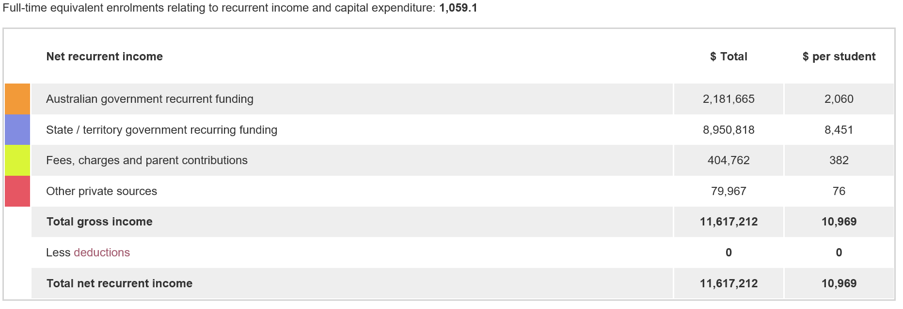

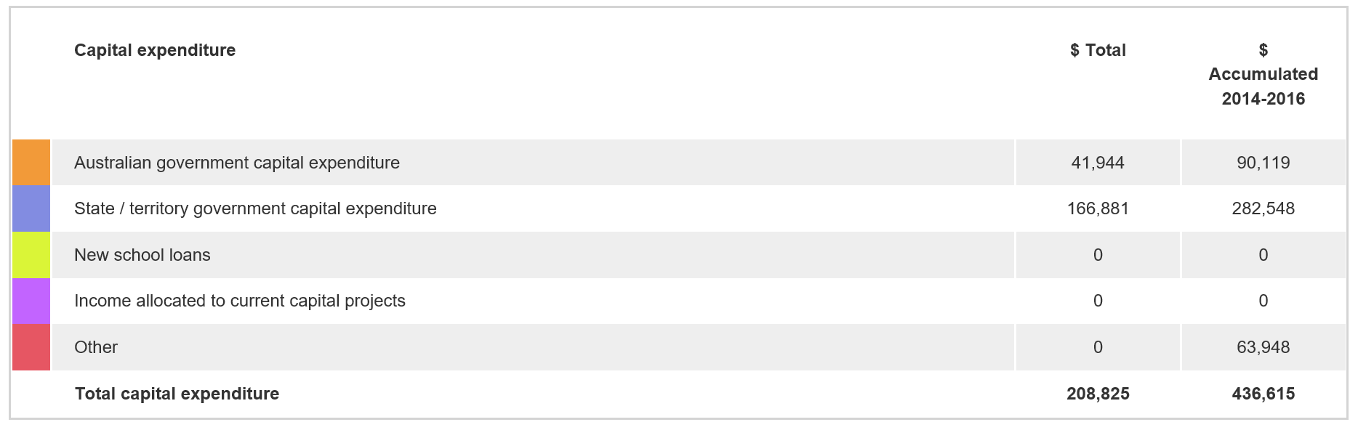

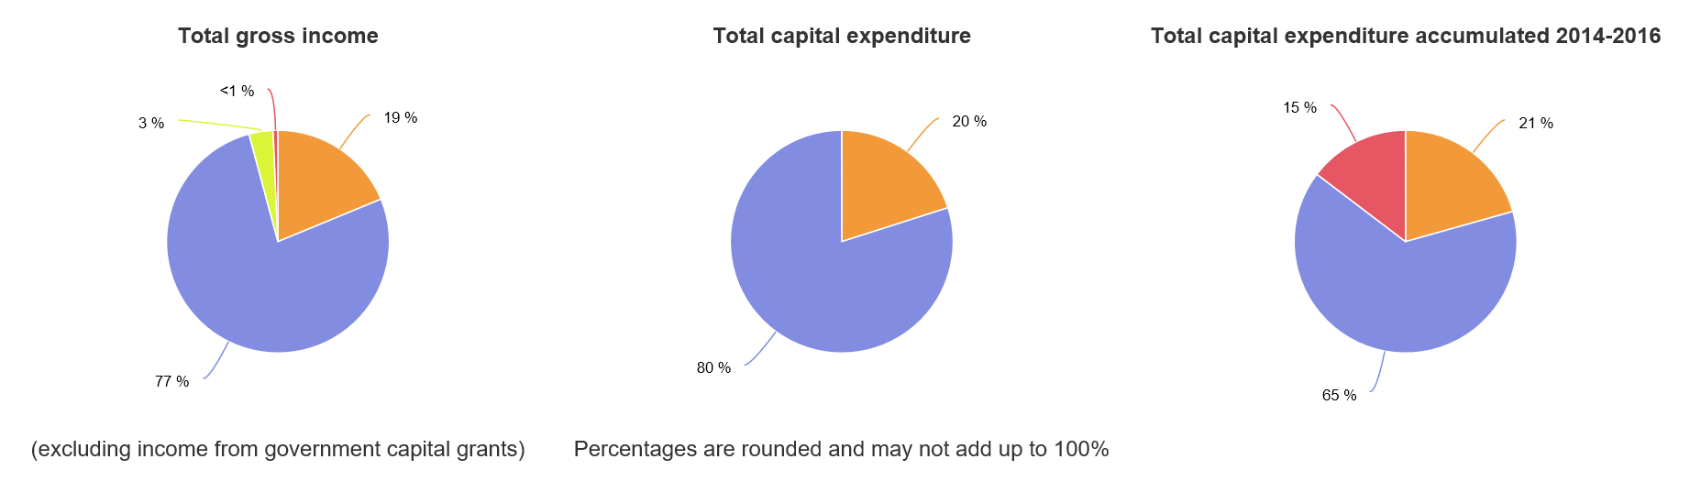To access our income details, click on the *My School* link above. You will then be taken to the *My School* website with the following **‘Find a school’ text box.**

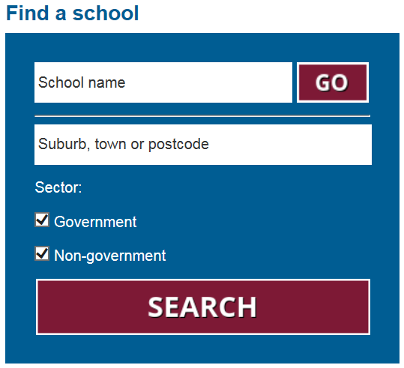

Where it states **‘School name’**, type in the name of the school you wish to view, select the school from the drop-down list and select <GO>. Read and follow the instructions on the next screen; you will be asked to confirm that you are not a robot then by clicking continue, you acknowledge that you have read, accepted and agree to the **Terms of Use** and **Privacy Policy** before being given access to the school’s *profile* webpage.

School financial information is available by selecting **‘School finances’** in the menu box in the top left corner of the school’s profile webpage. If you are unable to access the internet, please contact the school for a paper copy of income by funding source.

|  |
| --- |
| Our Staff Profile |
|  |

**Workforce Composition**

**Staff composition, including Indigenous staff**

| **2017 WORKFORCE COMPOSITION** | | | |
| --- | --- | --- | --- |
| **Description** | **Teaching Staff** | **Non-Teaching Staff** | **Indigenous Staff** |
| Headcounts | 71 | 33 | <5 |
| Full-time Equivalents | 65 | 23 | <5 |

**Qualification of all teachers**

| **TEACHER* QUALIFICATIONS** | |
| --- | --- |
| **Highest level of qualification** | **Number of classroom teachers and school leaders at the school** |
| Doctorate |  |
| Masters | 2 |
| Graduate Diploma etc.** | 5 |
| Bachelor degree | 66 |
| Diploma | 5 |
| Certificate |  |
| *Teaching staff includes School Leaders  **Graduate Diploma etc. includes Graduate Diploma, Bachelor Honours Degree, and Graduate Certificate. | |

**Professional Development**

**Expenditure On and Teacher Participation in Professional Development**

The total funds expended on teacher professional development in 2017 were $ **62938.40**.

The major professional development initiatives are as follows:

* Australian Professional Standards for Teachers
* Developing Individual Learning Plans
* Coaching for teachers to support the implementation of our Reading and Number priority areas
* The Disability Standards for Education, Queensland School Leaders for Inclusive Practice workshops
* Anaphylaxis Training
* Code of Conduct and Student Protection Training
* Asbestos Management Training
* Australian Curriculum implementation sessions
* Regional coaching and curriculum professional learning events
* Using data to analyse student achievement and inform teaching and learning
* Regional network meetings
* Art and Science of Teaching – all classroom teaching staff released to develop Reading
* Guaranteed and Viable Curriculum and Proficiency Scales and tracking tools for Maths and
* Reading
* Beginning Teachers
* Moderation
* STEM
* Sprints – Inquiry Cycle

The proportion of the teaching staff involved in professional development activities during 2017 was 83 %.

**Staff Attendance and Retention**

**Staff attendance**

| **AVERAGE STAFF ATTENDANCE (%)** | | | |
| --- | --- | --- | --- |
| **Description** | **2015** | **2016** | **2017** |
| Staff attendance for permanent and temporary staff and school leaders. | 94% | 95% | 95% |

**Proportion of Staff Retained from the Previous School Year**

From the end of the previous school year, 98% of staff was retained by the school for the entire 2017.

|  |
| --- |
| Performance of Our Students |
|  |

**Key Student Outcomes**

**Student Attendance**

**Student attendance**

The table below shows the attendance information for all students at this school:

|  |  |  |  |
| --- | --- | --- | --- |
| **STUDENT ATTENDANCE 2017** | | | |
| **Description** | **2015** | **2016** | **2017** |
| The overall attendance rate* for the students at this school (shown as a percentage). | 93% | 94% | 93% |
| The attendance rate for Indigenous students at this school (shown as a percentage). | 86% | 91% | 88% |
| *The student attendance rate is generated by dividing the total of full-days and part-days that students attended, and comparing this to the total of all possible days for students to attend, expressed as a percentage. | | | |

The overall student attendance rate in 2017 for all Queensland Primary schools was 93%.

| **AVERAGE STUDENT ATTENDANCE RATE* (%) FOR EACH YEAR LEVEL** | | | | | | | | | | | | | |
| --- | --- | --- | --- | --- | --- | --- | --- | --- | --- | --- | --- | --- | --- |
| **Year Level** | **Prep** | **Year 1** | **Year 2** | **Year 3** | **Year 4** | **Year 5** | **Year 6** | **Year 7** | **Year 8** | **Year 9** | **Year 10** | **Year 11** | **Year 12** |
| 2015 | 94% | 92% | 93% | 93% | 93% | 93% | 92% |  |  |  |  |  |  |
| 2016 | 95% | 93% | 93% | 94% | 94% | 93% | 93% |  |  |  |  |  |  |
| 2017 | 95% | 93% | 93% | 93% | 93% | 93% | 93% |  |  |  |  |  |  |
| *Attendance rates effectively count attendance for every student for every day of attendance in Semester 1. The student attendance rate is generated by dividing the total of full-days and part-days that students attended, and comparing this to the total of all possible days for students to attend, expressed as a percentage.  DW = Data withheld to ensure confidentiality. | | | | | | | | | | | | | |

**Student Attendance Distribution**

The proportions of students by attendance range:



**Description of how non-attendance is managed by the school**

Non-attendance is managed in state schools in line with the Department of Education procedures, *Managing Student Absences* *and Enforcing Enrolment and Attendance at State Schools* and *Roll Marking in State Schools*, which outline processes for managing and recording student attendance and absenteeism.

Helensvale State School has an attendance plan which is led by a Deputy Principal. In 2016 our SMS

Parent alert program was introduced and has continued throughout 2017 advising parents that their child was absent by 9:45am each day.

Absences and lateness to school are followed up initially with letters, emails and then meetings are arranged with parents of students were non-attendance is not reasonable and affecting schooling and learning outcomes.

School attendance initiatives include, a weekly class attendance competition, regular attendance information in the Homelines newsletter, posters around the school promoting EVERYDAY COUNTS.

**NAPLAN**

Our reading, writing, spelling, grammar and punctuation, and numeracy results for the Years 3, 5, 7 and 9 are available via the My School website at <http://www.myschool.edu.au/>.

To access our NAPLAN results, click on the My School link above. You will then be taken to the My School website with the following **‘Find a school’ text box.**



Where it states **‘School name’**, type in the name of the school you wish to view, select the school from the drop-down list and select <GO>. Read and follow the instructions on the next screen; you will be asked to confirm that you are not a robot then by clicking continue, you acknowledge that you have read, accepted and agree to the **Terms of Use** and **Privacy Policy** before being given access to the school’s *profile* webpage.

School NAPLAN information is available by selecting **‘NAPLAN’** in the menu box in the top left corner of the school’s profile webpage. If you are unable to access the internet, please contact the school for a paper copy of our school’s NAPLAN results.

|  |
| --- |
| Conclusion |
|  |

Helensvale is a thriving school community focused on Teaching and Learning. More information

about our school can be found at our website <https://helensvaless.eq.edu.au/Pages/default.aspx> or Facebook page or by contacting the school.